COVID-19 Detection in Chest X-ray Images Using Swin-Transformer and Transformer in Transformer
- The Coronavirus Disease 2019 (COVID-19) has spread globally and caused serious damages. Chest X-ray images are widely used for COVID-19 diagnosis and Artificial Intelligence method can assist to increase the efficiency and accuracy.
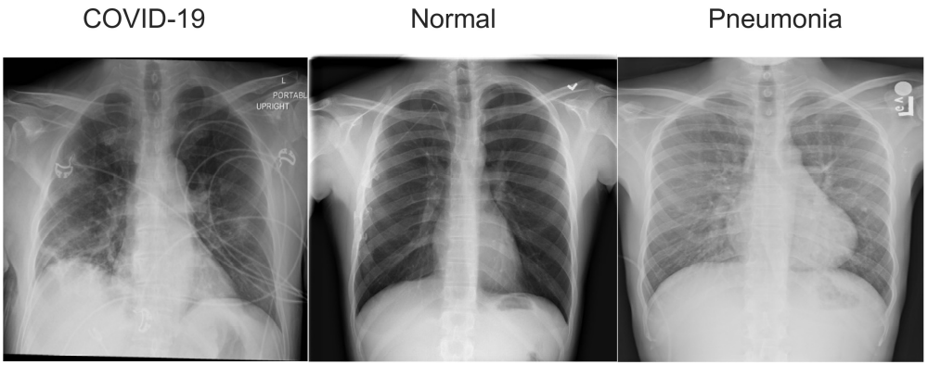

- We combined Swin-transformer and Transformer in Transformer to classify chest X-ray images as three classes as COVID-19, Pneumonia and Normal (healthy) on the dataset offered by the challenge organizer and achieved 0.9475 accuracy on test set.
- The dataset of this challenge contains three parts, which are used to train, validate and test respectively:
Train = 17,955 chest X-ray images
validation = 3,430 chest X-ray images
test = 1,200 chest X-ray images
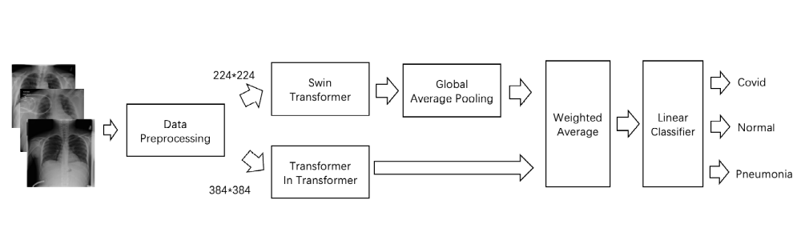
- Firstly, we resized the images to a certain scale (224*224 or 384*384), then applied random flipping, then selected a policy from rotation, translation horizontally or vertically, and then we applied random erasing.
- Finally, we did the normalization. All these changes are applied with small probability.
- Our implementation is based on PyTorch and mm classification and one NVIDIA Tesla-V100 GPUs are used for training. Model training is done by using the AdamW, where initial learning rate, batch size and weight decay set to 0.001, 64 and 0.05 respectively.
- We obtained the probabilities for each classes from two models, then calculated the weighted average for these probabilities. Finally, a linear classifier was used to get the results for classification.
- More specifically, our final results are:
Accuracy Score: 0.9475,
Sensitivity Score: 0.9475
Specificity Score: 0.9509
- In this paper, we applied Swin Transformer and Transformer in Transformer to classify the chest X-ray images in In the Challenge of Chest XR COVID-19 detection and did model ensemble by using weighted average method. We achieved 0.9475 accuracy on test set and ranks 10 on the leader board.

